# CS 340 README

## About the Project/Project Title

The project title is Project 2 and it uses the CS 340 Austin Animal Center (AAC) database. This project was requested by Grazioso Salvare to create a dashboard with geolocation mapping, user interaction, and charts in order to find dogs that are good candidates in reference to search and rescue situations. This project allows the user to search the AAC database, which holds the animal shelter csv information to search using a filter for these dog candidates.

Prior to the creation of Project 2, the AAC database was created and the animal shelter.csv was imported into the AAC database. Next, I created code in order to create admin and user information to access AAC database to find and/or modify information within the AAC database. Lastly, the animalShelter.py file was created in order to create CRUD methods for the AAC database.

## Getting Started

1. The first step is to enter Mongo and then import the aac_shelter_outcome.csv file into the AAC database and animals collection within your local port by using mongoimport. After import, verify the documents were imported and check if both the database and collection were created.
2. The second step is to create a simple and compound index for these documents within the AAC database.
3. The third step is to create an admin and user account to allow the user to readWrite the documents within AAC.animals.
4. The fourth step is to check if your newly created login information works in order to manipulate the documents within the AAC database.
5. The fifth step is to create both ipynb and py files to use the animalShelter and Project 2 files, but also be able to test these codes.
6. Run the Project 2 file to access the information, data table, geolocation, and chart.

## Tools

Python is utilized for the created files because this project uses .py and .ipynb files.

MongoDB needs to be installed because it is used to access the entire project.

PyMongo / Dash / Plotly / Pandas / Leaflet – these libraries are utilized in order to create functions with the project 2 file. These libraries allow driver to be accessed for Mongo, create tables, data frames, charts (pie charts, bar charts, etc.), and geolocation map.

Jupyter Notebook was used to create and write ipynb files. Furthermore, Jupyter was used to run files to check the output of the files when testing them of their function.

Spyder IDE was used in order to create py files because Jupyter Notebook was running into an internal server error when attempting to change the ipynb file to a py file by download.

## Usage

### User creation and tests code



Admin account creation and log in

AAC database account creation and log in

### CRUD animalShelter.py file

**(Change: Line 30 and 31 for the read method were commented out for this project)**

**Project2 ipynb file:**

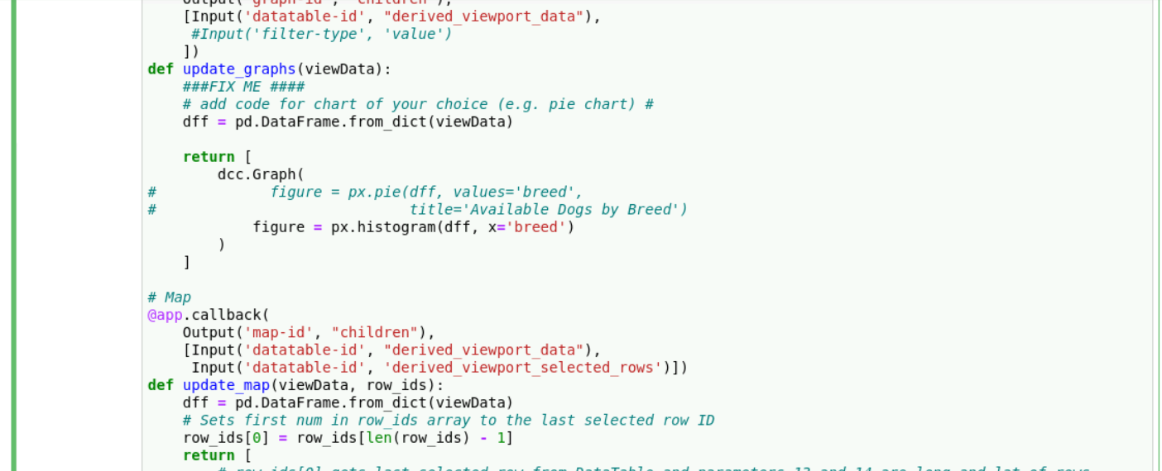

**Examples:**

(**Grazioso Salvare png file**)

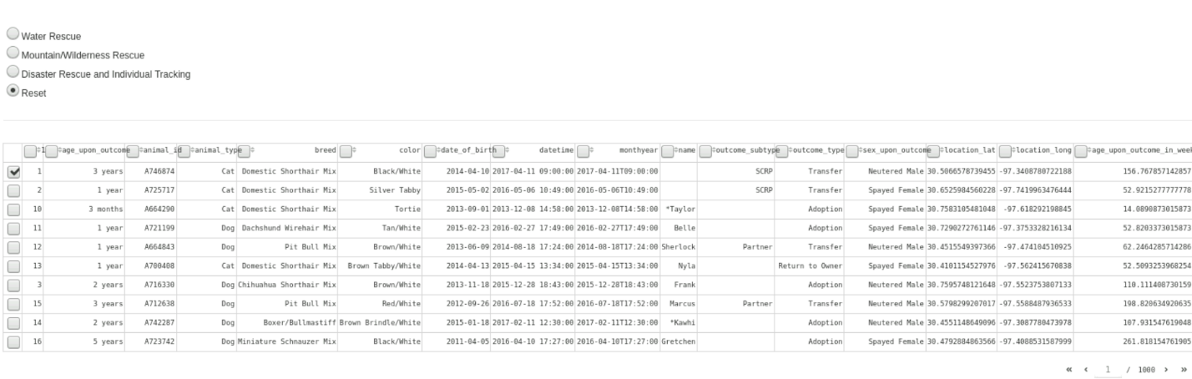

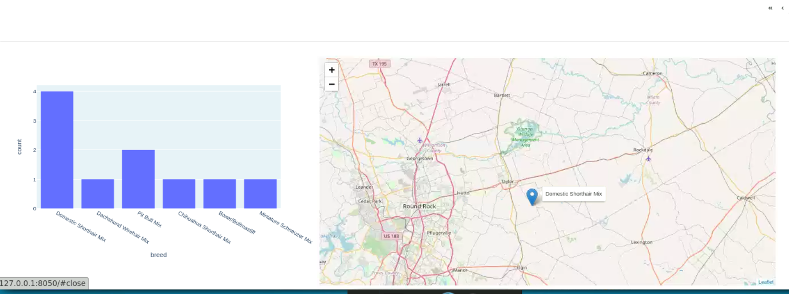

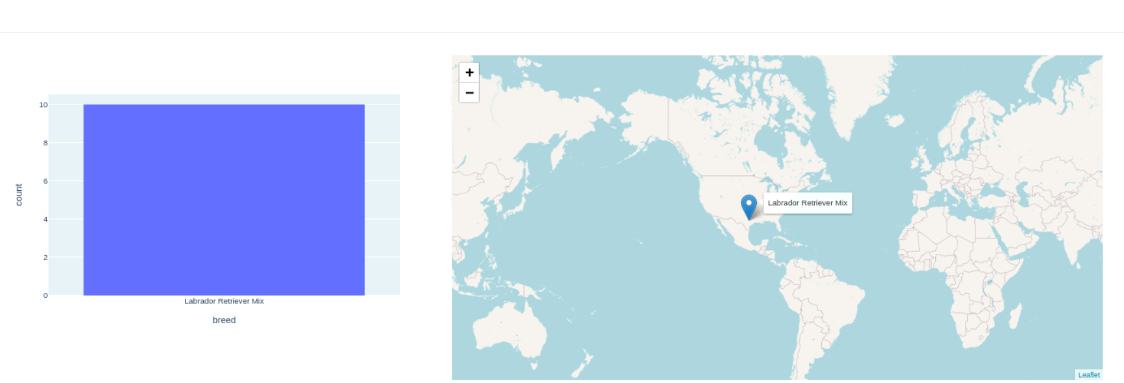

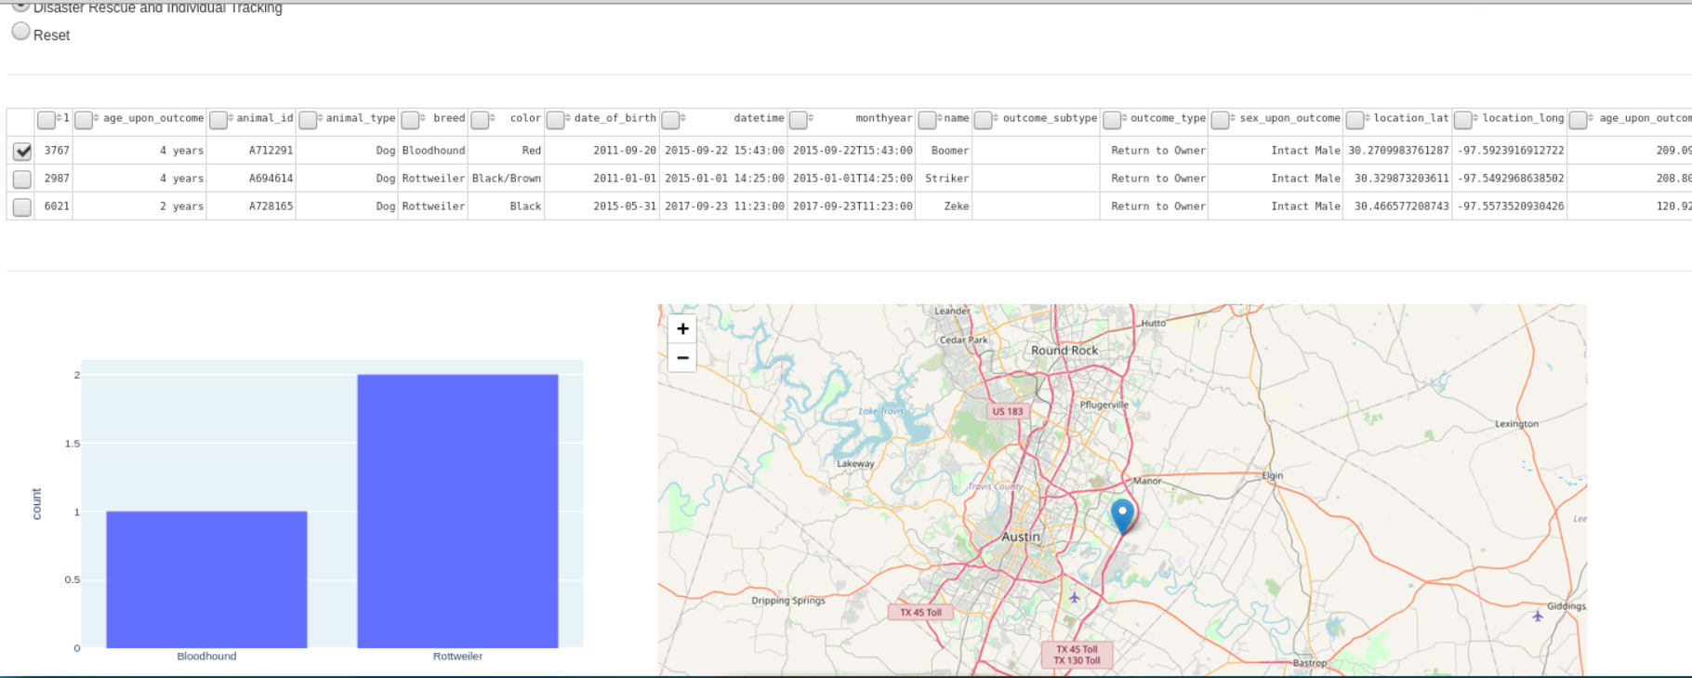

**(Choosing Disaster Rescue button – the dash site gets updated. The table, geolocation, and table updates due to the choice of the user.**

**Errors:**

1. The first error was unable to download an ipynb file to a py file using jupyter notebook. I was able to go around this by using spyder IDE to change the ipynb file to a py file.
2. The second error I ran into when creating these files was having the information from AAC csv file being returned as a clump of data instead of a table. The way it was fixed was by commenting out line 30 and 31 in my CRUD animalShelter.py file.
3. The third error was new windows not opening regardless of the internet connection being wireless or ethernet. The additional window for the project 2 ipynb file continued to load but refused to open. I was able to fix this issue by changing the final line of debug=True to debug=False.

## Contact

Talha Shafiq